WHAT is it?
The revaluation program involves the reappraisal of all real estate in the Town in order to bring about uniformity in property valuations and to assure that all property owners are paying only their fair share of the cost of essential community services. The equalization of property values is not intended to raise revenues; its purpose is to value all properties by the same standard at the same point in time.

WHY are we doing this?
The last complete revaluation of all real estate in the Town was done in 1983. Since then changes in economic conditions have caused inequities to develop. The only solution to this problem is to equalize all real estate and bring assessments up to date with current market value.

WHO will be involved?
ALL property owners will be involved to the extent the process consists of conducting a physical inspection of both the interior and exterior of each property in the Town. This is done to ensure that accurate property information is utilized in estimating each property's market value.

The successful bidder is Maine Assessment Appraisal Services, Inc. Garnett Robinson is the owner of the company, headquartered in Dixmont, ME and these are the folks you might see around town:
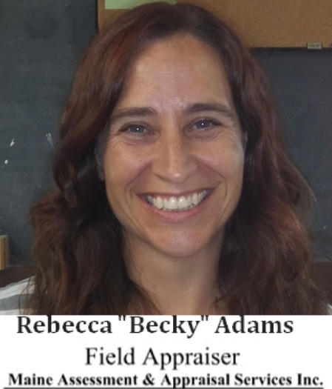

WHEN will it happen?
Work will begin August 1, 2018 and most property visits will take place during the first 6-8 months of the project.

WHERE can I get more information?
You can always call the Town Selectboard and Administrator at 589-3014. Updates will be posted on the Town's WEB page at http://www.libertymaine.us/home.html and on the Town's Facebook page at https://www.facebook.com/Liberty-Maine-Community-News-930246173684605/

