MINUTES
LIBERTY SELECTBOARD
January 8, 2018 7:00 PM

Selectboard Attendance: Melinda Steeves, 1st Selectman
Carrie Peavey, 2nd Selectman
Henry Hall, 3rd Selectman
Town Officials: Administrator Kenn Ortmann
Guest(s): Gregory Sprowl

- Open Public Meeting: 7:18 PM

- Approve Minutes: Pursuant to review Selectman Peavey moved and Selectman Hall seconded approval of the January 2, 2018 minutes. Unanimous.

- Warrant Review and Approval: Done.

- Public Comment
  - Gregory Sprowl regarding "Alternative Energy Structures" warrant article: The Selectboard discussed Mr. Sprowl's draft warrant article and TA Ortmann's observations. The possible need for additional definitions, including the word "practical" as used in the proposed language, and the issue of height restrictions were discussed. Mr. Sprowl plans to meet with DEP representatives tomorrow and will review these issues with them. Mr. Sprowl asked to be put on the agenda for next week.

- TA informational items
  - Media stories: None.
  - Resident correspondence: None.
  - TA Ortmann office hours this week: TA Ortmann explained he would not be in the office on Thursday. The Selectboard is fine with him working longer hours Tuesday and coming in either Wednesday or Friday.
  - Other: None.

- Old Business
  - FY19 Town Budget discussion:
  - Other: None.

- New Business
  - Cost of mailing Annual Reports: TA Ortmann noted that he is researching the cost, but preliminary estimates are between $1,500 and $2,000.
  - Shoveling around Town Office building: The Selectboard discussed the need to have someone on call to shovel the entrance way and to insure there is egress from the two back exits. Selectman Hall will contact Anthony Fuller about his interest in contracting to do this work. TA Ortmann will contact the individual plowing out the Davis residence behind the Town Office if Mr. Fuller is not interested or unavailable.
  - Other: None.

- Other Business: None.

- Adjournment: 9:05 PM

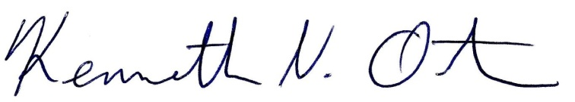
Respectfully submitted,

Kenn Ortmann
Town Administrator

