MINUTES
LIBERTY SELECTBOARD
February 5, 2018 7:00 PM

Selectboard Attendance: Melinda Steeves, 1st Selectman
Carrie Peavey, 2nd Selectman
Henry Hall, 3rd Selectman
Town Officials: Administrator Kenn Ortmann, Elise Brown, EMA Director & Budget Committee member
Guest(s): Susan Longley

- Open Public Meeting: 7:04 PM

- Approve Minutes: Pursuant to review Selectman Steeves moved and Selectman Hall seconded approval of the January 29, 2018 minutes. Unanimous.

- Warrant Review and Approval: Done.

- Public Comment: Susan Longley discussed the E. Coli problem last summer. There are various theories about what might have caused the high reading including a contaminated sample, runoff from the construction of a nearby leach field, hay bales in the water, and the combination of a low water level and many ducks in the area. Ms. Longley suggested being more proactive if this happens again. TA Ortmann volunteered to reach out to other communities for examples of best management practice policies and procedures.

- TA informational items
  - Media stories: None.
  - Resident correspondence
    - Marilyn Belenger letter regarding E. coli issue last summer: TA Ortmann will write a letter acknowledging receipt of her letter.
    - Jeff Davis regarding interest in Planning Board: TA Ortmann shared Mr. Davis's correspondence with the Selectboard.

- Old Business
  - FY19 Town Budget discussion: TA Ortmann reviewed latest budget spreadsheet. Elise Brown shared that she did reach out to Wayne Van Duysen of the American Vets Food Pantry and discussed their Social Service request for $2,000. The Food Pantry also receives some support from Montville and Searsmont, but the majority of support and of recipients comes from Liberty. She recommends supporting their full request.
    - Joint meeting with Montville Selectboard to discuss Ambulance service: Elise Brown volunteered to contact Montville officials to inquire about setting up a meeting.
  - Annual Report progress update: TA Ortmann noted most reports are in and he anticipates meeting the schedule discussed several weeks ago.
  - Cost of mailing Annual Reports: TA Ortmann shared that we still do not have information on this.
  - Harris upgrade update: TA Ortmann noted he has discussed this issue with Harris. The upgrade is necessitated by Microsoft no longer supporting the Access Database software. He told Harris that we will plan to make the shift to the "SQL" database system in 2019.
  - Other: None.

- New Business: None.

- Other Business: None.

- Adjournment: 9:15 PM

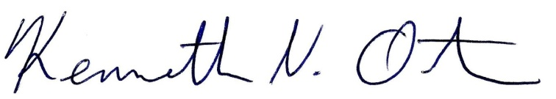
Respectfully submitted,

Kenn Ortmann
Town Administrator

