MINUTES
LIBERTY SELECTBOARD
February 12, 2018 7:00 PM

Selectboard Attendance: Melinda Steeves, 1st Selectman
Carrie Peavey, 2nd Selectman
Henry Hall, 3rd Selectman
Town Officials: Administrator Kenn Ortmann, Treasurer Betsey Davis
Guest(s): None

- Open Public Meeting: 7:05 PM

- Approve Minutes: Pursuant to review Selectman Peavey moved and Selectman Hall seconded approval of the February 5, 2018 minutes. Unanimous.

- Warrant Review and Approval: Done.

- Public Comment: Treasurer Betsey Davis reported on the contacts she has made with property owners who are delinquent on their taxes and whose property is now moving toward foreclosure.

- TA informational items
  - Media stories: None.
  - Resident correspondence: None.
  - TA Office schedule: None.

- Old Business
  - FY19 Town Budget discussion: On the basis of feedback from Montville Officials the plan is for essentially identical warrant articles so there is no need for a joint meeting with the Montville Selectboard to discuss Ambulance service.
  - Annual Report progress update: TA Ortmann reviewed the current draft with the Selectboard and will make several revisions. The Selectboard is planning to get together on Sunday, March 4 at 2 PM to apply mailing labels to the annual reports.
  - Planning Board appointments: TA Ortmann was asked to send a letter to Planning Board Alternate Steve Chapin thanking him for his letter of interest in moving to a full position and noting the Selectboard is taking his request under advisement.
  - Cost of mailing Annual Reports: TA Ortmann is still working on this issue.
  - Other: None

- New Business: None.
  - Other

- Other Business: None.

- Adjournment: 8:25 P.M.

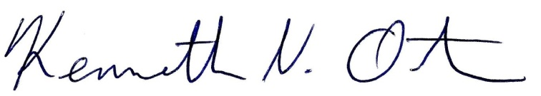
Respectfully submitted,

Kenn Ortmann
Town Administrator

