MINUTES
LIBERTY SELECTBOARD
February 19, 2018 7:00 PM

Selectboard Attendance: Melinda Steeves, 1st Selectman
Henry Hall, 3rd Selectman
Excused (scheduling conflict): Carrie Peavey, 2nd Selectman
Town Officials: Administrator Kenn Ortmann
Guest(s): None

- Open Public Meeting: 7:05 PM

- Approve Minutes: Pursuant to review Selectman Steeves moved and Selectman Hall seconded approval of the February 12, 2018 minutes. Unanimous.

- Warrant Review and Approval: Done.

- Public Comment: None.

- TA informational items
  - Media stories: None.
  - Resident correspondence: None.
  - WEB site update: TA Ortmann he plans to work on this project next week while he is visiting his Dad in Minnesota.

- Old Business
  - Annual Report progress update: The Selectboard reviewed the reports and suggested a few additional changes.
  - Cost of mailing Annual Reports: TA Ortmann explained that once he uploads the TRIO database to the USPS program it will print out the labels and calculate the mailing cost.
  - Other: None.

- New Business
  - Tree Growth application: The Selectboard took under advisement the application from Todd Allison & Laetitia Kieffer.
  - Tax Lien Procedures Program: The Selectboard suggested asking Gail Philippi and Hannah Hatfield if they are interested in attending.
  - Other: None.

- Other Business: None.

- Adjournment: 7:55 PM

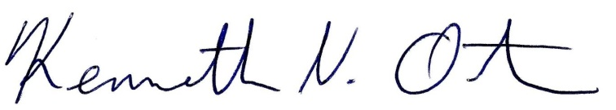
Respectfully submitted,

Kenn Ortmann
Town Administrator

