MINUTES
LIBERTY SELECTBOARD
February 26, 2018 7:00 PM

Selectboard Attendance: Melinda Steeves, 1st Selectman
Carrie Peavey, 2nd Selectman
Henry Hall, 3rd Selectman
Town Officials: Fire Chief Bill Gillespie
Guest(s): Kerrie Black, Marijuana Committee

- Open Public Meeting: 7:00 PM

- Approve Minutes: Pursuant to review Selectman Steeves moved and Selectman Peavey seconded approval of the February 19, 2017 minutes. Unanimous.

- Warrant Review and Approval: Done.

- Public Comment: Kerri Black from the Marijuana Committee updated the Selectboard that of our neighboring towns, Washington has adopted a moratorium, Palermo is waiting to see what we do, and Searsmont and Montville have done nothing to date. There seems to be little discussion about his issue by the public. The Committee will continue to follow this issue but is likely to meet less frequently until the State has taken meaningful action.

- Old Business
  - Annual Report progress update: TA Ortmann reported by email that the annual report is at the printer and is scheduled to be delivered to the Town Office March 3.
  - Cost of mailing Annual Reports: TA Ortmann also reported by email that the cost is still undetermined. The Post Office conducted some computer upgrades over the weekend and now their system is not working.
  - Tree Growth application: The Selectboard agreed to review the application following the meeting.
  - Other
    - Fire Truck: Fire Chief Gillespie updated the Selectboard on the status of construction of the new Fire Truck. It is ¾ completed and Chief Gillespie will be traveling to Florida to conduct an inspection the first week in April. Chief Gillespie also noted he is working with Treasurer Davis regarding the accounts paying for the new vehicle.
    - Tax Lien Procedures Program: The Selectboard agreed that Gail Philippi, Jamie Davis and Hannah Hatfield should all attend this training opportunity.

- New Business
  - Discussion with Fire Chief and Road Commissioner regarding proposed compensation: The Selectboard and Fire Chief Gillespie discussed the changing salary amounts over the past several years. It was agreed that FY19 compensation amounts would be further discussed at Town Meeting.
  - Other
    - Tri-Town Jaws account distribution: Fire Chief Gillespie updated the Selectboard on the fact that Liberty's share of the account was $5,600. When the Town received the funds, Chief Gillespie obligated $4,900 of the funds for "Jaws" equipment. It was his belief that the remaining $700 would be rolled over to be spent at a later date. It was his belief that the $500 voted for the Tri Town Jaws account at the March 19, 2016 Town meeting would also be rolled over after the Tri Town organization was dissolved. Since this did not happen, this places him in the position of having $1,200 less to support this piece of equipment than he believed was available.

- Other Business: None.

- Adjournment: 8:20 PM

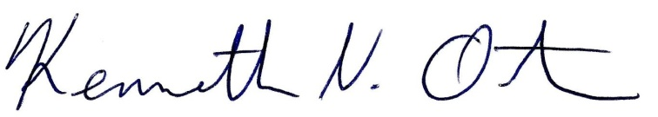
Respectfully submitted,

Kenn Ortmann
Town Administrator

