MINUTES
LIBERTY SELECTBOARD
March 5, 2018 7:00 PM

Selectboard Attendance: Melinda Steeves, 1st Selectman
Carrie Peavey, 2nd Selectman
Henry Hall, 3rd Selectman
Town Officials: Administrator Kenn Ortmann
Guest(s): Steve Chapin

- Open Public Meeting: 7:07 PM

- Approve Minutes: Pursuant to review Selectman Steeves moved and Selectman Peavey seconded approval of the February 26, 2018 minutes. Unanimous.

- Warrant Review and Approval: Done.

- Public Comment: Steve Chapin discussed with the Selectboard the rationale behind the proposed revaluation, whether or not the problems identified can be solved another less expensive way, the assessing program (TRIO), and assessing agents.

- TA informational items
  - Media stories: None.
  - Resident correspondence: TA Ortmann informed the Selectboard about correspondence from Melanie Ripley regarding the Selectman nomination process, the requirements for Fire Chief and Fire Department expenditures, the Tax Map Coordinator responsibilities, the process for electing the Clerk, the Town Administrator position, conflicts of interest, the process for electing a Treasurer, the TRIO program, and the Snowplowing contract bidding specifications. The Selectboard noted that these issues have been addressed in the past.
  - TA Ortmann office schedule: TA Ortmann informed the Selectboard that he plans to take another short trip to Minnesota for family matters between March 13 and 18.

- Old Business
  - Annual Report mailing update: TA Ortmann reported the Annual Reports have been mailed to all individuals showing as property owners in TRIO as of February 13, 2018.
  - Other: The Selectboard officially signed the Town Meeting Warrant to be posted March 6.

- New Business
  - Meeting with Marijuana Committee: None. See discussion during February 26 meeting.
  - Montville Warrant language for the LVAS budget: Selectboard reviewed and noted differences due to the different budget cycles.
  - Other:

- Other Business: None.

- Adjournment: 9:04 PM

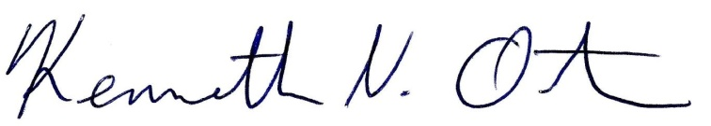
Respectfully submitted,

Kenn Ortmann
Town Administrator

