MINUTES
LIBERTY SELECTBOARD
March 19, 2018 7:00 PM

Selectboard Attendance: Melinda Steeves, 1st Selectman
Carrie Peavey, 2nd Selectman
Henry Hall, 3rd Selectman
Town Officials: Administrator Kenn Ortmann
Guest(s): Matt Wilson, University of Maine student

- Open Public Meeting: 7:05 PM

- Approve Minutes: Pursuant to review Selectman Steeves moved and Selectman Peavey seconded approval of the March 12, 2018 minutes. Unanimous.

- Warrant Review and Approval: Done.

- Public Comment: Mr. Wilson, a resident of Liberty and a University of Maine student explained he is sitting in on the Selectboard meeting as part of a government class requirement.

- TA informational items
  - Media stories: None.
  - Resident correspondence: TA Ortmann shared an Email from Justin McMann from Maine Revenue Services asking about a convenient time to visit to gather information and review sales. We will suggest some times at the next Selectboard meeting.

He also shared an email from Denise Glick stating her support of the revaluation and the new office hours, and asking if more can be done to protect Prescott Hill Road from the impact of heavy trucks. He noted that Road Commissioner Reynolds has already responded to the roadway issue.

TA Ortmann noted a copy of correspondence from Attorney Kelly to Mr. Sprowl reminding Mr. Sprowl of his obligation to reimburse the Town, by March 30, for the legal fees incurred in our litigation with him.

- Old Business
  - Annual Town Meeting issues: None.
  - Revaluation public informational session: Scheduled for Wednesday evening, March 21 at 7 PM even though snow is forecast for that evening.
  - Snow shoveling around Town Office and Community Hall: Selectman Hall will contact Luke Davis to discuss shoveling arrangements for the Town Office and Community Hall.
  - Other: None.

- New Business: None.

- Other Business: None.

- Adjournment: 8:12 PM

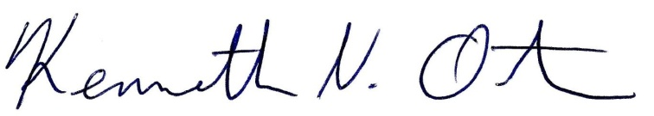
Respectfully submitted,

Kenn Ortmann
Town Administrator

