MINUTES
LIBERTY SELECTBOARD
March 26, 2018 7:00 PM

Selectboard Attendance: Melinda Steeves, 1st Selectman
Carrie Peavey, 2nd Selectman
Henry Hall, 3rd Selectman
Town Officials: Administrator Kenn Ortmann
Guest(s): None

- Open Public Meeting: 7:00 PM
Second Selectman Carrie Peavey was sworn into office by Town Clerk Gail Philippi.

- Approve Minutes: Pursuant to review Selectman Steeves moved and Selectman Peavey seconded approval of the March 19, 2018 minutes. Unanimous.

- Warrant Review and Approval: Done.

- Public Comment: None.

- TA informational items
  - Media stories: None.
  - Resident correspondence: None
  - RSU 3 correspondence regarding Board membership: The Selectboard discussed the Board Apportionment issue and asked TA Ortmann to invite Betty-Lu Davis and Richard Frost to attend the next Selectboard meeting April 2 to discuss this issue prior to the April 3 meeting called by the School Superintendent. Selectmen Hall and Peavey will attend the April 3 meeting if their schedules permit.

- Old Business
  - Annual Town Meeting issues: None.
  - Select potential meeting dates with Justin McMann: TA Ortmann will contact Mr. McMann about his availability Tuesdays at 1 PM.
  - Snow shoveling: Contact Luke Davis if there is additional need this season.
  - Other: None.

- New Business
  - Appointments: The Selectboard signed Certificates of Appointment for Kenn Ortmann as Town Administrator, Steve Chapin as regular Planning Board member, Jeff Davis as regular Planning Board member, Elise Brown as EMA Director, Don Harrison as Code Enforcement Officer and as Plumbing Inspector, Heidi Blood as Animal Control Officer, Henry Hall as TCSWMO representative, Dana Philippi as alternate TCSWMO representative, and Gail Philippi as Mapping Coordinator, E911 Addressing Officer, and Registrar of Voters.
  - RFP for revaluation: The Selectboard reviewed two examples from Maine communities and decided to use the Brunswick example as a prototype. TA Ortmann will work on a draft for review at the next meeting.
  - RFP for mowing: The Selectboard reviewed a version updated from last year and approved publicizing the RFP.
  - Meeting with WAO Scholarship Board: TA Ortmann will contact Dawn Bowen to try to set up a meeting at a regular Selectboard meeting.
  - TRIO Motor Vehicle module contract: Selectboard signed the contract with Harris to allow for training to be scheduled with the proviso that no payments for this module will occur until after the beginning of the new fiscal year.
  - Other: None.

- Other Business: None.

- Adjournment: 8:53 PM

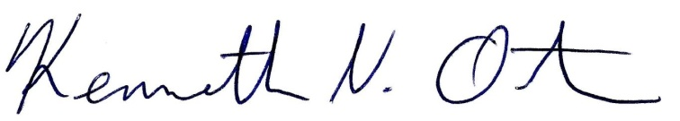
Respectfully submitted,

Kenn Ortmann
Town Administrator

