MINUTES
LIBERTY SELECTBOARD
April 16, 2018 7:00 PM

Selectboard Attendance: Melinda Steeves, 1st Selectman
Carrie Peavey, 2nd Selectman
Henry Hall, 3rd Selectman
Town Officials: Administrator Kenn Ortmann
Guest(s): None

- Open Public Meeting: 7:02 PM

- Approve Minutes: Pursuant to review Selectman Steeves moved and Selectman Peavey seconded approval of the April 9, 2018 minutes with one clarification incorporated in the final approved version. Unanimous.

- Warrant Review and Approval: Done.

- Public Comment: None.

- TA informational items
  - Media stories: None.
  - Resident correspondence: None.
  - FY2019 projected municipal revenue sharing: TA Ortmann shared that Liberty is anticipated to receive $44,918.24 for FY19. For comparison we received $41,343.37 in FY18, $36,878.16 in FY17, and $36,261.58 in FY16.
  - TA Ortmann office schedule next week: TA Ortmann noted that he will be out of the office Thursday April 26 for a family visit.

- Old Business
  - RFP for revaluation – draft review: TA Ortmann reviewed suggested changes to the draft reviewed last week. The most significant are to let responders explain how they plan to maximize interior inspections, to increase the penalty for not completing the project on time, to require a sketch component compatible with TRIO, and to specify the income approach to determining non-residential values as a last approach only if the sales comparison and cost approaches don't provide adequate information.
  - RFP for mowing – status update: TA Ortmann noted that Montville is also looking for bidders, they have shared their contact list, and he is sending those nine companies a copy of our RFP.
  - Post Card to property owners – update: The postage check was approved and signed tonight so the cards will be mailed tomorrow morning.
  - Municipal investment options research and scheduling meeting with WAO Scholarship Board: TA Ortmann will follow up with Toni Clark tomorrow on possible meeting dates.
  - Sprowl litigation cost reimbursement update: TA Ortmann will follow up with Mr. Sprowl tomorrow with deadline to sign agreement next Monday.
  - Other: None.

- New Business
  - HL Whitney Certificate of Appointment as Marshall Shore Staff: Signed.
  - Local Health Officer appointment: TA Ortmann noted he has received a resignation email from Steven Chapin. While we have no specific job description we do have examples from other Maine communities that describe the responsibilities. He will send a letter to Steven thanking him for his service.
  - Planning Board resignation: TA Ortmann noted he has received a resignation email from Steven Chapin. He will send a letter to Steven thanking him for his service.
  - Other: None.

- Other Business: None.

- Adjournment: 7:54 PM

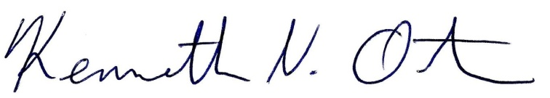
Respectfully submitted,

Kenn Ortmann
Town Administrator

