DRAFT MINUTES
LIBERTY SELECTBOARD
April 30, 2018 7:00 PM

Selectboard Attendance: Melinda Steeves, 1st Selectman
Carrie Peavey, 2nd Selectman
Henry Hall, 3rd Selectman
Town Officials: Administrator Kenn Ortmann, Fire Chief Bill Gillespie, Road Commissioner Tammy Reynolds
Guest(s): None

- Open Public Meeting: 7:05 PM

- Approve Minutes: Pursuant to review Selectman Steeves moved and Selectman Peavey seconded approval of the April 23, 2018 minutes with one correction incorporated in the final version. Unanimous.

- Warrant Review and Approval: Done.

- Public Comment: None.

- TA informational items
  - Media stories: None.
  - Resident correspondence: None.

- Old Business
  - RFP for revaluation – status update: TA Ortmann reported the RFP has been published on the MMA website and will be published this week in the Republican Journal. He has had one inquiry so far and has forwarded a copy of the RFP to Garnett Robinson.
  - Mowing bids - update: A letter was sent to the successful bidder and his insurance certificate was received. Letters were also sent to the unsuccessful bidders.
  - Sprowl litigation cost reimbursement update: Selectmen Steeves and Peavey reported on their visit with Mr. Sprowl and provided a copy of a signed agreement. TA Ortmann will record the lien tomorrow and send certified notice to Mr. Sprowl about recording the lien.
  - Local Health Officer appointment: Selectman Steeves moved and Selectman Peavey seconded appointment of Jordan Ray as Liberty Health Officer. Unanimous.
  - Planning Board regular and alternate openings: TA Ortmann noted the continuing vacancies.
  - Other – Stumpage Agreement for Harvest of Town woodlots: Road Commissioner Reynolds brought in a copy of the proposed agreement (Intent to Harvest # 465567) along with Worker's Comp and Liability Insurance documents. Selectman Steeves moved and Selectman Hall seconded approving the agreement. Unanimous.

- New Business
  - Nominations to MMA's Legislative Policy Committee: TA Ortmann shared this opportunity with the Selectboard.
  - Other: None.

- Other Business: TA Ortmann reported that the Midcoast Conservancy is interested in providing paddling programming on Stevens Pond again this year. The Selectboard supports the program.

- Adjournment: 7:56 PM

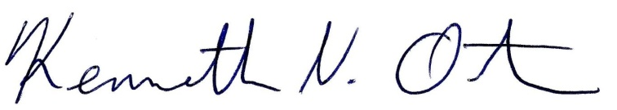
Respectfully submitted,

Kenn Ortmann
Town Administrator

