MINUTES
LIBERTY SELECTBOARD
May 7, 2018 7:00 PM

Selectboard Attendance: Melinda Steeves, 1st Selectman
Carrie Peavey, 2nd Selectman
Henry Hall, 3rd Selectman
Town Officials: Administrator Kenn Ortmann, Fire Chief Bill Gillespie, CEO Don Harriman
Guest(s): None

- Open Public Meeting: 7:05 PM

- Approve Minutes: Pursuant to review Selectman Steeves moved and Selectman Peavey seconded approval of the April 30, 2018 minutes. Unanimous.

- Warrant Review and Approval: Done.

- Officials/Public Comment: The Selectboard discussed with CEO Harriman the deteriorating condition of the building on Map 18 Lot 36 and their specific concern for the safety of children who might play in the vicinity. CEO Harriman will mention this issue at the Planning Board meeting Thursday when the owner has an item on the agenda and TA Ortmann will send correspondence to the property owner sharing the Selectboard's concerns and asking for a plan of action with a timeframe.

- TA informational items
  - Media stories: None.
  - Resident correspondence: None.

- Old Business
  - RFP for revaluation – status update: TA Ortmann noted there has been a second request for a full copy of the RFP. The deadline for receipt of proposals is May 17, 2018 at 1 PM.
  - Planning Board regular and alternate openings: The Selectboard discussed the two openings and will continue to think about individuals who might be interested in serving.
  - Other: None.

- New Business
  - MMA's fiscal survey: TA Ortmann noted this is a voluntary survey that will be fairly time consuming to complete. The Selectboard agreed that other responsibilities have a higher priority this year.
  - Other: None.

- Other Business
  - Tour of new Fire Truck (around 7:30 PM): Fire Chief Gillespie had the Selectboard release the Fire Truck construction bond now that we have taken possession of the vehicle. He then demonstrated the ladder operation and explained the various features of the new vehicle.

- Adjournment: 7:56 PM

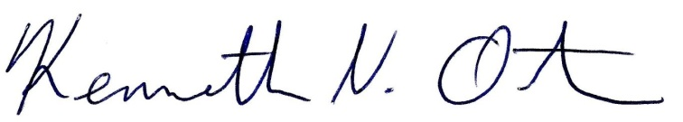
Respectfully submitted,

Kenn Ortmann
Town Administrator

