DRAFT MINUTES
LIBERTY SELECTBOARD
July 2, 2018 7:00 PM

Selectboard Attendance: Melinda Steeves, 1st Selectman
Carrie Peavey, 2nd Selectman
Henry Hall, 3rd Selectman
Town Officials: Administrator Kenn Ortmann, Fire Chief Bill Gillespie
Guest(s): None

- Open Public Meeting: 7:02 PM

- Approve Minutes: Pursuant to review Selectman Steeves moved and Selectman Peavey seconded approval of the June 25, 2018 minutes. Unanimous.

- Warrant Review and Approval: Done.

- Officials/Public comments: Fire Chief Bill Gillespie reported that he has sold both excess vehicles for $6,000. He also noted that Engine Company 7 wants to donate the revenue from the boot drive and the annual 4th of July Chicken BBQ toward the extrication equipment cutter attachment. Selectman Peavey moved and Selectman Steeves seconded accepting a donation from Engine Company 7 to be applied toward the purchase of the extrication equipment cutter attachment. Unanimous.

Chief Gillespie also noted that he is working on replacing three dry hydrants this year. The Selectboard suggested he contact the Citizens' Association of Liberty Lakes as a courtesy and talk with Road Commissioner Reynolds about possible permitting requirements.

- TA informational items
  - Media stories: None.
  - Resident correspondence: None.
  - Other: TA Ortmann reminded the Selectboard that legislation last year increased the State's reimbursement rate for Homestead Exemptions from 50% to 62.5% effective April 1, 2018. There have been some problems with TRIO not being updated properly, so we will have to pay attention to this issue when we do our commitment.

TA Ortmann also noted that Liberty Craft Brewing has provided us with a copy of their outdoor entertainment schedule and Le Mesa will not be offering any outdoor entertainment this year.

- Old Business
  - Real Estate Sketching – TRIO proposal: TA Ortmann provided the Selectboard with a copy of the invoice to be signed for this TRIO module that will be used extensively throughout the revaluation project.
  - Copying tax maps: TA Ortmann noted that the price quotes from Staples in Rockland and from Quality Copy in Hallowell were within a few dollars of each other. Selectman Steeves said she travels to Rockland daily, and is willing to drop off the maps at no cost to the Town. TA Ortmann will prepare the Maps for copying and provide the contact information to Selectman Steeves.
  - Other: None.

- New Business
  - FY19 School Assessment information: TA Ortmann provided a copy a letter from RSU 3 estimating Liberty's share from July 2018 through June 2019 as $1,373,884.55. The State has still not finalized the level of support it will provide local school districts, but RSU is estimating it will be a little over $250,000. It is anticipated the figure will be finalized before the end of July.
  - Other: None

- Other Business: None.

- Adjournment: 7:49 PM

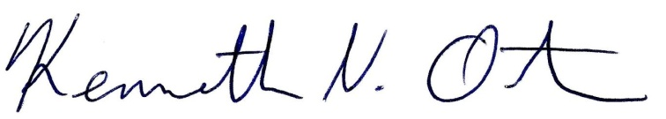
Respectfully submitted,

Kenn Ortmann
Town Administrator

