DRAFT MINUTES
LIBERTY SELECTBOARD
July 9, 2018 7:00 PM

Selectboard Attendance: Melinda Steeves, 1st Selectman
Carrie Peavey, 2nd Selectman
Henry Hall, 3rd Selectman
Town Officials: Administrator Kenn Ortmann
Guest(s): Clerk/Tax Collector Gail Philippi, Treasurer Hannah Hatfield, Steve Fountain

- Open Public Meeting: 7:00 PM

- Approve Minutes: Pursuant to review Selectman Steeves moved and Selectman Peavey seconded approval of the July 2, 2018 minutes. Unanimous.

- Warrant Review and Approval: Done.

- Officials/Public comments: Clerk/Tax Collector Gail Philippi shared that she is taking some vacation time in August. Jamie Davis, her Deputy, will be covering the days she is away.

Steve Fountain described his plans for a self-storage facility across from the Circle-K on Route 3 on Map 8 Lot 23. He plans to take down the existing large metal sign and replace it with a smaller sign supported by wooden posts. Maine DOT wants to know if the Town has any objections to the sign replacement. The Selectboard crafted and signed a statement stating that the Town has no objections.

The Selectboard asked Treasurer Hannah Hatfield to compile information from accounts that might be used to help pay for dam repair costs to be discussed next week.

- TA informational items
  - Media stories: None.
  - Resident correspondence: None.

- Old Business: None.

- New Business
  - Planning Board candidate interviews: TA Ortmann shared that Betty-Lu Davis is not able to attend the meeting this evening but plans to attend next Monday. He has not heard from Richard Light. The Selectboard asked that both be informed about the Planning Board meeting on July 12th and invited to attend it and the July 16th Selectboard meeting.
  - Meeting with Road Commissioner Tammy Reynolds and CALL President Linda Breslin to discuss the Spillway Dam at Lake Saint George and the dam at Stevens Pond: TA Ortmann stated that he misunderstood that the meeting request is for next week, not this week.
  - Waldo County Budget Committee nomination request: TA Ortmann shared with the Board the request for nominations.
  - Other: None.

- Other Business: The Selectboard discussed the possibility of changing their meeting time from 7-9 PM to 6-8 PM. There will be further discussion at the meeting next week.

- Adjournment: 7:46 PM

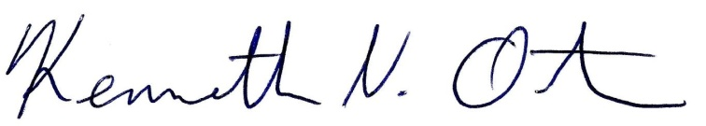
Respectfully submitted,

Kenn Ortmann
Town Administrator

