MINUTES
LIBERTY SELECTBOARD
August 27, 2018 7:00 PM

Selectboard Attendance: Melinda Steeves, 1st Selectman
Carrie Peavey, 2nd Selectman
Henry Hall, 3rd Selectman
Town Officials: Administrator Kenn Ortmann, Emergency Management Director Elise Brown
Guest(s): None

- Open Public Meeting: 7:00 PM

- Approve Minutes: Pursuant to review and a typo correction Selectman Steeves moved and Selectman Peavey seconded approval of the August 20, 2018 minutes. Unanimous.

- Warrant Review and Approval: Done

- Officials/Public comments
  - Inquiry about cataloging Liberty cemeteries: TA Ortmann shared an email from Kate Ahlefeld referencing a Republican Journal article about an intern helping Union catalog all burial sites in the community. The Selectboard asked TA Ortmann to research the internship program and to see if Treasurer Hatfield has any knowledge of this program.
  - Letter from Governor LaPage: TA Ortmann shared a letter from Governor LaPage sharing his concerns about the legislative override of his veto of LD 700, "An Act to Give Flexibility to Employees and Employers for Temporary Layoffs".

- TA informational items
  - Media stories: None.
  - Revaluation project status report: TA Ortmann reported that Maine Assessment & Appraisal Services, Inc. was able to complete 125 property visits last week and has now moved on to non-waterfront accounts.
  - TA Schedule this week: TA Ortmann reported that he will not be in the office Thursday this week.

- Old Business
  - Liberty Volunteer Ambulance Service discussion meeting date: Emergency Management Director Elise Brown reported on the LVAS Board meeting yesterday and how she believes another meeting with LVAS and the Liberty and Montville Selectboards will be helpful. She will check to see if a meeting September 28th is possible.
  - Planning Board candidate interviews: None.
  - Digital Map project RFP responses: TA Ortmann reported that he has not yet had time to review the proposals.
  - Workplace tobacco policy information: TA Ortmann presented a revised policy that prohibits smoking in the Town Office, and within 20 feet of the entrance. After discussion Selectman Hall moved and Selectman Peavey seconded approval of the policy. Unanimous.
  - Option for supplementary "cloud" back up: Postponed to next meeting.
  - Other - WAO investment strategy: Selectman Hall reported that the most attractive CD interest rates are not available to municipalities. TA Ortmann will check with MMA to see if they have any advice and will ask on the Managers/Administrators list-serve for advice from other communities.

- New Business
  - Set commitment date and time: Given employment obligations, the only time the entire Selectboard can be present is evenings. TA Ortmann will contact Garnett Robinson to see if he is available to help walk us through the commitment process this year. While Harris technical assistance won't be available, the hope is Mr. Robinson's assistance will help us avoid problems. The first choice is Tuesday, September 11th at 5:30 PM and the second choice is Wednesday, September 12 at 5:30 PM.
  - Other: None.

- Other Business: None.

- Adjournment: 8:07 PM

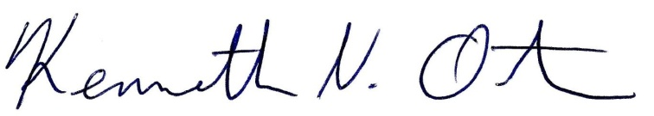
Respectfully submitted,

Kenn Ortmann
Town Administrator

