MINUTES
LIBERTY SELECTBOARD
October 29, 2018 7:00 PM

Selectboard Attendance: Melinda Steeves, 1st Selectman
Carrie Peavey, 2nd Selectman
Henry Hall, 3rd Selectman
Town Officials: Administrator Kenn Ortmann
Guest(s): None

- Open Public Meeting: 7:02 PM

- Approve Minutes: Pursuant to review Selectman Hall moved and Selectman Peavey seconded approval of the October 22, 2018 minutes. Unanimous.

- Warrant Review and Approval: Done.

- Officials/Public comments: None.

- TA informational items
  - Media stories: None.
  - Revaluation project status report: None.
  - 2019 Maine DOT proposed Liberty projects: TA Ortmann shared Maine DOT correspondence showing their proposed 2019 work on Route 105 and on Trues Pond Road. He has forwarded the information to Road Commissioner Reynolds and Fire Chief Gillespie.
  - New school speed limit sign: TA Ortmann reported that after a resident pointed out how difficult it is to read the hours posted on the existing school speed limit sign, Road Commissioner Reynolds contacted Maine DOT and convinced them to send us a bigger sign.

- Old Business
  - Option for supplementary "cloud" back up: TA Ortmann will continue to request a price quote.
  - Digital Tax Map project discussion: TA Ortmann reported that references provided by CAI, and one user that was not a reference, have been uniformly positive about their experiences with the company.
  - Other: None.

- New Business
  - Sample "Internal Financial Controls Policy" discussion: TA Ortmann shared an example from China, ME that Treasurer Hatfield has reviewed and thinks will provide a good template we can modify for our purposes. The Selectboard supports the Treasurer investing some time creating a policy for Liberty. TA Ortmann will also check to see if MMA has templates we can review.
  - Trash complaint on Boynton Road: TA Ortmann reported on the complaint. It appears as though it is on private property so the Town has no jurisdiction. The Selectboard suggested sending the information on to Road Commissioner Reynolds for her information.
  - MMA manual purchases in addition to Planning Board?: TA Ortmann asked if we should order any other manuals. The Selectboard suggested ordering the General Assistance, General Assistance Ordinance (Guidelines), and the Board of Appeals manuals in addition to the Planning Board manual.
  - Other: None.

- Other Business: None.

- Adjournment: 8:10 PM

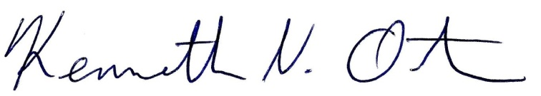
Respectfully submitted,

Kenn Ortmann
Town Administrator

