MINUTES
LIBERTY SELECTBOARD
November 19, 2018 7:00 PM

Selectboard Attendance: Melinda Steeves, 1st Selectman
Carrie Peavey, 2nd Selectman
Henry Hall, 3rd Selectman
Town Officials: Administrator Kenn Ortmann
Guest(s): None

- Open Public Meeting: 7:07 PM

- Approve Minutes: Pursuant to review Selectman Steeves moved and Selectman Peavey seconded approval of the November 5, 2018 minutes. Unanimous.

- Warrant Review and Approval: Done.

- Officials/Public comments: None.

- TA informational items
  - Media stories: None.
  - Revaluation project status report: TA Ortmann reported that he is sending information to Mr. Robinson regarding the utility requests for an explanation about their increased assessments this year. The Selectboard also asked TA Ortmann to see when Mr. Robinson might want to meet with the Assessors regarding the revaluation project..

- Old Business
  - Other: None.

- New Business
  - Office and Selectboard holiday schedule for 2019: The Selectboard reviewed the list of State and Federal holidays and identified which ones they would observe and which ones they would wait to decide on based on issues and workload.
  - CMP Town pole permit application – Crie Hill off Cox Rd (Boynton Rd?): The Selectboard reviewed and signed the application.
  - Other: None.

- Other Business: None.

- Adjournment: 7:45 PM

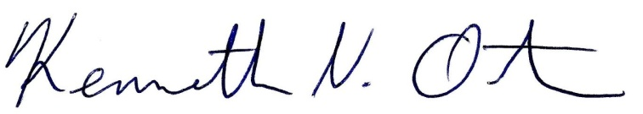
Respectfully submitted,

Kenn Ortmann
Town Administrator

