MINUTES
LIBERTY SELECTBOARD
November 26, 2018 7:00 PM

Selectboard Attendance: Melinda Steeves, 1st Selectman
Carrie Peavey, 2nd Selectman
Henry Hall, 3rd Selectman
Town Officials: Administrator Kenn Ortmann, Planning Board Chair Peter Mallow
Guest(s): None

- Open Public Meeting: 7:00 PM

- Approve Minutes: Pursuant to review Selectman Peavey moved and Selectman Hall seconded approval of the November 19, 2018 minutes. Unanimous.

- Warrant Review and Approval: Done.

- Officials/Public comments
  - Dennis Urick to discuss resource protection setbacks impact on value of his property: Mr. Urick did not attend the meeting.
  - Planning Board Chair Peter Mallow: Mr. Mallow informed the Selectboard that he has to be out of town the day of the next Planning Board meeting and that the Planning Board has not elected a Vice Chair. Because Planning Board rules state the Vice Chair shall run the meeting in the absence of the Chair, Mr. Mallow requested guidance on how to proceed. It was the consensus of the Selectboard that postponing the meeting to the following week with proper notice to the applicants and public is the best solution. Mr. Mallow will notify TA Ortmann about the specific details so he can publish notice on our WEB site and post it in the Town Office.

- TA informational items
  - Media stories: None.
  - Revaluation project status report: TA Ortmann informed the Selectboard that he has forwarded the requested utility information to Mr. Robinson. TA Ortmann will send acknowledgement to the utilities regarding their request. TA Ortmann will also follow up with Mr. Robinson about a meeting date with the Selectboard.

- Old Business
  - Option for supplementary "cloud" back up: The Selectboard agreed that our current system is adequate.
  - Other: None.

- New Business
  - Initial research on new phone system for Town Office: TA Ortmann presented research into a small business package from Vtech. If we don't replace the two portable handsets on the Selectman's desks, the package will cost $470. TA Ortmann will do some additional research and bring a proposal back to the Selectboard next week.
  - New WEB site activation: TA Ortmann noted that he has been working on getting our new WEB site ready for activation and he plans to activate the new site tomorrow.
  - Other: None.

- Other Business: None

- Adjournment: 7:43 PM

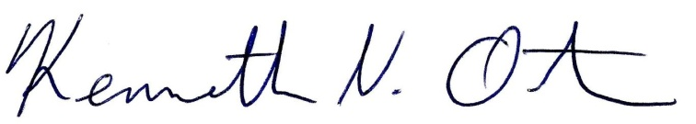
Respectfully submitted,

Kenn Ortmann
Town Administrator

