MINUTES
LIBERTY SELECTBOARD
December 10, 2018 7:00 PM

Selectboard Attendance: Melinda Steeves, 1st Selectman
Carrie Peavey, 2nd Selectman
Henry Hall, 3rd Selectman
Town Officials: Administrator Kenn Ortmann, Gail Philippi, Town Clerk/Tax Collector/Town Agent
Guest(s): Garnett Robinson, Maine Assessment & Appraisal Services

- Open Public Meeting: 7:04 PM

- Approve Minutes: Pursuant to review Selectman Peavey moved and Selectman Hall seconded approval of the December 3, 2018 minutes. Unanimous.

- Warrant Review and Approval: Done

- Officials/Public comments
  - Meeting with Garnett Robinson, Maine Assessment & Appraisal Services: Mr. Robinson noted the project is ahead of schedule. There was considerable discussion about recent case law that will affect how multiple non-contiguous properties currently on one tax bill will be treated in the future. The Selectboard and Mr. Robinson agreed to schedule a public informational meeting for February 11, 2019 at 6 PM. TA Ortmann stated he would see if TRIO can produce a report of the accounts and property owners that may be affected so we can notify them directly about the meeting.

Mr. Garnett has not yet contacted Shari Irish of Avangrid to address her questions about our assessment versus the declared value for both CMP and MEPCO. TA Ortmann asked to be kept in the loop with respect to that communication. TA Ortmann was asked to check with the Planning Board about any utility applications they have reviewed.

TA Ortmann asked Mr. Robinson to provide an estimate of the annual Assessors Agent cost so we can include that amount in our budget deliberations and to prepare a Town Meeting warrant article.

- TA informational items
  - Media stories: None.
  - Revaluation project status report: See comments above.

- Old Business
  - Research on change to Building Notification section 4.2: TA Ortmann noted that the OCR conversation from a hard copy to a MSWord document created a typo that he has since corrected so no action is needed.
  - Recommendation for new phone system for Town Office: Pending further research.
  - Other: None.

- New Business
  - FY20 budget: TA Ortmann provided a first draft showing historic line item amounts and expenditures through November. There are several changes he recommends considering that will make our document more consistent with the Audit Report.
  - January 5 "Day of Service": TA Ortmann shared information about this initiative. The Selectboard will think about possible projects.
  - Other: None.

- Other Business: None.

- Adjournment: 8:43 PM

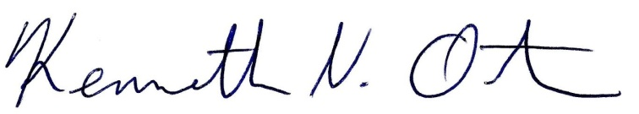
Respectfully submitted,

Kenn Ortmann
Town Administrator

