MINUTES
LIBERTY SELECTBOARD
December 17, 2018 7:00 PM

Selectboard Attendance: Melinda Steeves, 1st Selectman
Carrie Peavey, 2nd Selectman
Henry Hall, 3rd Selectman
Town Officials: Administrator Kenn Ortmann
Guest(s): None

- Open Public Meeting: 7:00 PM

- Approve Minutes: Pursuant to review Selectman Peavey moved and Selectman Steeves seconded approval of the December 10, 2018 minutes. Unanimous.

- Warrant Review and Approval: Done.

- Officials/Public comments: None.

- TA informational items
  - Media stories: None.
  - Revaluation project status report: No update.

- Old Business
  - Recommendation for new phone system for Town Office: Still pending.
  - Draft revaluation information meeting postcard: TA Ortmann showed the list of 175 TRIO accounts including more than one lot. He does not know how many include contiguous lots and how many have lots separated by a road. After considerable discussion the Selectboard agreed to send post cards to all 175 accounts notifying them of the February 11, 2019 6 PM informational meeting with Garnett Robinson to discuss how recent case law will affect how some of the lots are treated for taxing purposes.
  - FY20 budget: TA Ortmann reviewed the FY19 budget worksheet and noted some line items that are not included in the warrant but are broken out in the Treasurer's Report and/or in the Audit. He will check with Road Commissioner Reynolds and Fire Chief Gillespie about the appropriate line items for mileage and electricity. He will also ask Treasurer Hatfield to create a Traffic Control line item under Town Operations. Finally, he presented a report showing that about one-third of the Town budget is comprised of fixed costs like our snowplowing contract, debt service, insurance, solid waste, the audit, and software maintenance and support fees.
  - Other: None.

- New Business
  - Insurance coverage of Swimming Program: TA Ortmann reported on his communication with Kat and Darlene Newcombe and MMA regarding insurance coverage for the program. The Selectboard has no problem with treating them as employees to obtain insurance coverage. TA Ortmann will remind them that they still need to comply with lifeguard certification standards.
  - Building Permit tracking system: TA Ortmann noted that CEO Harriman currently files Intent to Build forms with the Selectboard. If we have an Assessor's Agent we will create a folder for the Agent to review on a monthly basis.
  - Annual report dedication: TA Ortmann asked the Board to think about this so we can begin working on the bio early in January.
  - Selectboard annual report: TA Ortmann also asked that the Selectboard begin working on this section as soon as possible.
  - Other: None.

- Other Business: None.

- Adjournment:

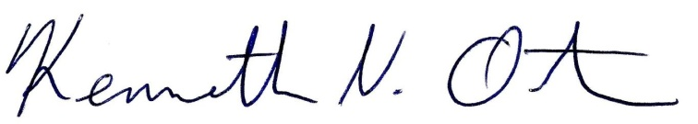
Respectfully submitted,

Kenn Ortmann
Town Administrator

