MINUTES
LIBERTY SELECTBOARD
January 28, 2019 6:00 PM

Selectboard Attendance: Melinda Steeves, 1st Selectman
Carrie Peavey, 2nd Selectman
Henry Hall, 3rd Selectman
Town Officials: Administrator Kenn Ortmann, Clerk/Tax Collector/ Registrar of Voters Gail Philippi
Guest(s): Budget Committee Chair Betsy Levine and members Elise Brown, Judy Fuller, Dorothy Harrison, and Joan Tax

- Open Public Meeting: 7:00 PM (following first hour of Budget Committee meeting)

- Approve Minutes: Pursuant to review Selectman Steeves moved and Selectman Peavey seconded approval of the January 21, 2019 minutes. Unanimous.

- Joint meeting with Budget Committee
  - FY20 budget: The Selectboard and Budget Committee reviewed the most recent draft spreadsheet and discussed each line item. TA Ortmann said he would incorporate the numbers into an updated spreadsheet and send back out for review..
  - Annual Meeting warrant: The Board and Committee also discussed how several articles might be configured to minimize confusion and allow for a methodical review at Town meeting. The most significant is the warrant dealing with the Ambulance Service. TA Ortmann said he would draft a revised version for review.

- Warrant Review and Approval: Done.

- Officials/Public comments: See Budget Committee comments above.

- TA informational items
  - Media stories: None.

- Old Business
  - Selectboard annual report: Pending
  - Other: None.

- New Business
  - Other: None.

- Other Business: None.

- Adjournment: 8:53 PM

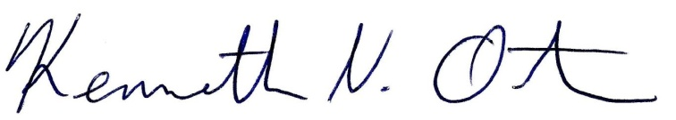
Respectfully submitted,

Kenn Ortmann
Town Administrator

