MINUTES
LIBERTY SELECTBOARD
February 11, 2019 5:30 PM

Selectboard Attendance: Melinda Steeves, 1st Selectman
Carrie Peavey, 2nd Selectman
Henry Hall, 3rd Selectman
Town Officials: Administrator Kenn Ortmann, Road Commissioner Tammy Reynolds
Guest(s): Dave St. Clair

- Open Public Meeting: 5:35 PM

- Approve Minutes: Pursuant to review Selectman Peavey moved and Selectman Hall seconded approval of the February 4, 2019 minutes. Unanimous.

- Warrant Review and Approval: Done.

- Officials/Public comments: None.

- TA informational items
  - Media stories: None.

- Old Business
  - FY20 Warrant
    - Selectboard Report: The Selectboard reviewed and agreed to the report change suggested by Selectman Peavey.
    - Assessor's Agent article wording: The Selectboard reviewed and agreed to the change in the article wording suggested by Town Meeting Moderator Andrew Worcester.
    - Parking warrant sections: Selectboard discussed and agreed to add an article authorizing the purchase of a tire "boot" to show the Town is serious about addressing the safety concerns associated with parking violations.
  - Other: None.

- New Business
  - Review of Mowing bids: The Selectboard opened the single bid received from Jalen Babin. His bid for one year is $17,000. His bid for 2020 is $18,000 and for 2021 is $19,000. After discussion Selectman Steeves moved and Selectman Peavey seconded accepting the three-year bid contingent on receiving required insurance. Unanimous.
  - Other: None.

- Other Business: None.

- Adjournment: 5:46 PM

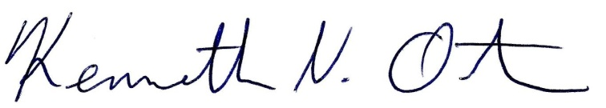
Respectfully submitted,

Kenn Ortmann
Town Administrator

