MINUTES
LIBERTY SELECTBOARD
February 18, 2019 6:00 PM

Selectboard Attendance: Melinda Steeves, 1st Selectman
Carrie Peavey, 2nd Selectman
Henry Hall, 3rd Selectman
Town Officials: Administrator Kenn Ortmann, EMA Director Elise Brown
Guest(s): None

- Open Public Meeting: 6:14 PM

- Approve Minutes: Pursuant to review Selectman Hall moved and Selectman Peavey seconded approval of the February 11, 2019 minutes. Unanimous.

- Warrant Review and Approval: Done.

- Officials/Public comments
  - Meeting with Elise Brown: EMA Director Brown discussed the Ambulance Service's request for funding from both Montville and Liberty and issues to be discussed at the Ambulance Service informational meeting scheduled for March 6.

- TA informational items
  - Media stories: None.
  - Revaluation project status report: TA Ortmann discussed adding information to the WEB site about the issue of multiple lots on one tax bill. The Selectboard agreed it will be helpful and suggested including the sample letter in the Annual Report.

- Old Business
  - Final approval of FY20 budget: TA Ortmann noted he has added dollar amounts for mowing and the Emergency Fund. The Selectboard reviewed the budget.
  - Final approval of FY20 Warrant: TA Ortmann also noted he also added dollar amounts for mowing and the Emergency Fund to the Town Meeting warrant.
  - Other: None.

- New Business
  - TRIO Microsoft SQL software upgrade: TA Ortmann noted the upgrade from Microsoft Access to Microsoft SQL will cost $2,650 and will need to be included in next year's budget.
  - PAWS Animal Adoption Center agreement: TA Ortmann asked the Selectboard to sign a one year agreement for the next fiscal year. The Selectboard asked TA Ortmann to check with MMA to see if we can enter into a 3-year contract for services like this.
  - Request by Aflac representative to meet with Selectboard next week: The Selectboard asked TA Ortmann to have the Aflac representative to speak directly to Fire Chief Gillespie to see if there is any interest in a presentation.
  - Other: None

- Other Business: Pursuant to discussion Selectman Steeves moved and Selectman Hall seconded accepting "back taxes" for Map 6 Lot 47, Account 281and authorizing a quit-claim back to Angie and David Harriman. Unanimous.

- Adjournment: 7:23 PM

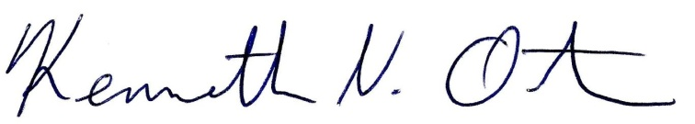
Respectfully submitted,

Kenn Ortmann
Town Administrator

