MINUTES
LIBERTY SELECTBOARD
June 10, 2019 6:00 PM

Selectboard Attendance: Melinda Steeves, 1st Selectman
Carrie Peavey, 2nd Selectman
Henry Hall, 3rd Selectman
Town Officials: Administrator Kenn Ortmann, Road Commissioner Tammy Reynolds
Guest(s): None

- Open Public Meeting: 6:02 PM

- Approve Minutes: Pursuant to review Selectman Steeves moved and Selectman Peavey seconded approval of the June 3, 2019 minutes. Unanimous.

- Warrant Review and Approval: Done.

- Officials/Public comments: Road Commissioner Reynolds reported that in response to notifying abutters about our intent to harvest wood from our woodlot off Plummer Road near the Palermo Town line, one abutter is contesting the boundary between our property and theirs. The Selectboard authorized Road Commissioner Reynolds to find a surveyor to establish the line with the intent to pay for the service from the harvest proceeds.

- TA informational items
  - Media stories: None.
  - Revaluation project status report: None.

- Old Business
  - Foreclosed property sales process: The Selectboard reviewed the list of foreclosed property and did not find any with value to the Town that we should keep. While no member of the Selectboard is potentially interested in purchasing any of the properties, they agreed that requesting sealed bids is likely to increase bids where there is interest. The Selectboard agreed to advertise once in the Republican Journal, with letters being sent directly to all abutters in case they have an interest. The Selectboard will not set any minimum price on the properties but wants language allowing them to reject any and all bids. Bidders will be required to include a Cashier's Check for the full amount of their bid. All property will be conveyed by quitclaim deed with the buyer responsible for all deed and transaction costs. The property and any improvements are being sold "as is". The intent is to have the bid opening scheduled about two weeks after the properties are advertised.
  - Other: None.

- New Business
  - Fuel pre-buy: TA Ortmann shared the history of fuel usage at the Fire Station, Town Office and Community Hall. The Selectboard agreed with the gallons recommended by Road Commissioner Reynolds and Fire Chief Bill Gillespie for the Community Hall and Fire Station respectively. They also agreed to order the average amount used per year since 2014 for the Town Office.
  - Other: None.

- "11th hour" items
  - Dam Emergency Exercise date and time: The Selectboard agreed to schedule this exercise for Monday, August 12 at 7 PM immediately following the regular Selectboard meeting.
  - Audit date and time: The Selectboard chose Thursday, July 18 to commence our FY19 audit.

- Adjournment: 6:53

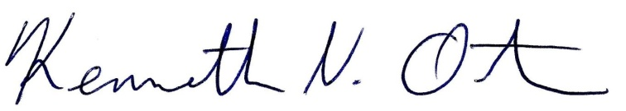
Respectfully submitted,

Kenn Ortmann
Town Administrator

