MINUTES
LIBERTY SELECTBOARD
July 15, 2019 6:00 PM

Selectboard Attendance: Melinda Steeves, 1st Selectman
Excused: Carrie Peavey, 2nd Selectman due to illness
Henry Hall, 3rd Selectman
Town Officials: Administrator Kenn Ortmann, Road Commissioner Tammy Reynolds
Guest(s): None.

- Open Public Meeting: 6:00 PM

- Approve Minutes: Pursuant to review Selectman Steeves moved and Selectman Hall seconded approval of the July 8, 2019 minutes. Unanimous.

- Warrant Review and Approval: Done.

- Officials/Public comments: Road Commissioner Reynolds noted the estimated cost to level the grounds at the Route 220 cemetery is $1,500, with much of the work consisting of manual labor moving wheelbarrows of loam. Pursuant to discussion Selectman Steeves moved and Selectman Hall seconded approval of the expenditure. Unanimous.

Road Commissioner Reynolds also noted that the survey of the contested woodlot boundary has been completed. Once the final report has been received and when weather and ground conditions are conducive, harvesting will begin.

- TA informational items
  - Media stories:
  - Revaluation project status report: TA Ortmann reported the plan is still to mail out the draft property cards next week. He will invite Garnett Robinson to the next Selectboard meeting to discuss land schedule values.

- Old Business
  - Recreational Marijuana workshop attendance: TA Ortmann will send another email to Marijuana Committee to see if there are two members who might be interested in attending the August 21 workshop.
  - Sale of tax-acquired properties - update: TA Ortmann noted there have been several inquiries to the Town Office about the properties.
  - Other: None.

- New Business
  - Tax Map GIS Conversion and Update Services Contract: TA Ortmann presented the contract for Selectboard signature.
  - Auditor visit July 18: TA Ortmann reminded the Selectboard about the auditor's first visit scheduled for Thursday.
  - Other: None.

- "11th hour" items
  - MMA annual election ballot: TA Ortmann presented the ballot, which has no contested races. The Selectboard voted for the proposed slate.
  - Budget vs. Actual July 2018 through June 2019 (Pre audit): TA Ortmann shared the draft summary of our actual FY19 expenditures compared to budgeted amounts. Several line items were well below the budgeted amount with a few slightly over. This draft, which will be adjusted through the audit process, shows we were under budget by approximately $128,000.
  - Trash/Diapers at Stevens Pond: Road Commissioner Reynolds noted a problem with diapers being left next to the porta-potty at Stevens Pond. In this instance Selectman Hall volunteered to remove and dispose of the diapers.
  - Fuller Bridge #3631 State inspection report: TA Ortmann noted we have received another copy of the report we received two years ago.

- Adjournment: 7:07 PM

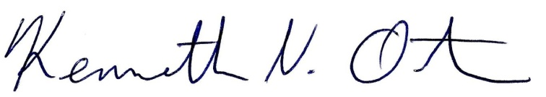
Respectfully submitted,

Kenn Ortmann
Town Administrator

