MINUTES
LIBERTY SELECTBOARD
August 12, 2019 6:00 PM

Selectboard Attendance: Melinda Steeves, 1st Selectman
Carrie Peavey, 2nd Selectman
Henry Hall, 3rd Selectman
Town Officials: Administrator Kenn Ortmann, Fire Chief Bill Gillespie
Guest(s): Waldo County District 1 Commissioner Betty I. Johnson, Drexel White, Midcoast District Public Health Liaison, Department of Health & Human Services

- Open Public Meeting: 6:00 PM

- Approve Minutes: Pursuant to review Selectman Steeves moved and Selectman Peavey seconded approval of the August 5, 2019 minutes with one minor correction. Unanimous.

- Warrant Review and Approval: Done.

- Officials/Public comments
  - Aging Well in Waldo County presentation by Sheriff Jeffrey Trafton & District 1 Commissioner Betty I. Johnson: Commissioner Johnson and Drexel White discussed the "Aging Well in Waldo County" program, answered questions, and asked the Selectboard to consider voting to have Liberty join the program. Selectman Steeves moved and Selectman Peavey seconded having TA Ortmann work with Joan Tax to complete the paperwork indicating Liberty's interest in joining the program. Unanimous.
  - Fire Chief Bill Gillespie: Chief Gillespie explained that the current management at the Waldo County Regional Communications Center is considering not renewing the contract for the "I AM RESPONDING" platform. He explained the many ways in which the use of this program allows local Fire Departments to operate much more efficiently and effectively by sharing needed information quickly. Selectman Peavey moved and Selectman Steeves seconded a motion to sign a letter to the Waldo County Commissioners asking that funding for this program remain in the budget. Unanimous.

- TA informational items
  - Media stories: None.
  - Revaluation project status report: TA Ortmann reported he is making appointments for tax payers to meet with Maine Assessment & Appraisal Services representatives. The Selectboard asked TA Ortmann to ask Garnett Robinson for guidance on how we should treat the "Personal Property" tax issue.

- Old Business
  - Marshall Shore parking correspondence: TA Ortmann noted some very thoughtful correspondence from resident Barbara Rehmeyer about how the parking enforcement program has had a side benefit of allowing some vegetation in the area to rejuvenate with less foot traffic.
  - Other: None.

- New Business
  - Other: TA Ortmann noted that we have received a Quitclaim Deed for one of the tax acquired properties we sold. Selectman Steeves moved and Selectman Peavey seconded authorizing TA Ortmann to sign the document. Unanimous.
  - Stevens Pond: Road Commissioner Tammy Reynolds reports the porta-potty has been tipped over twice in one week. She has called the rental company to have it removed.

- "11th hour" items: None.

- Adjournment: 7:10 PM

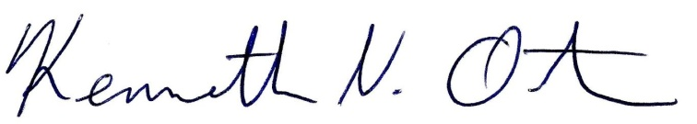
Respectfully submitted,

Kenn Ortmann
Town Administrator

