MINUTES
LIBERTY SELECTBOARD
August 19, 2019 6:00 PM

Selectboard Attendance: Melinda Steeves, 1st Selectman
Carrie Peavey, 2nd Selectman
Henry Hall, 3rd Selectman
Town Officials: Administrator Kenn Ortmann, Road Commissioner Tammy Reynolds
Guest(s): Richard Frost, School Board Representative, RSU #3

- Open Public Meeting: 6:02 PM

- Approve Minutes: Pursuant to review Selectman Peavey moved and Selectman Hall seconded approval of the August 12, 2019 minutes. Unanimous.

- Warrant Review and Approval: Done.

- Officials/Public comments
  - Meet with Richard Frost, School Board Representative, RSU #3: Mr. Frost shared that he has been elected Chair of the Board. He noted there are three new Board members this year, so along with the two new members last year, there has been significant turnover. He mentioned there have also been significant changes in administrative staff and principals. He also shared there has been a new Charter School, the Ecology Learning Center, for grades 9-12, approved for the campus of Unity College that will serve students from Waldo County. The school anticipates fewer than 100 students so he does not believe it will have a significant impact on RSU #3.

- TA informational items
  - Media stories: None.
  - Revaluation project status report: TA Ortmann reminded the Selectboard of the revaluation appointments beginning next Sunday. The Selectboard asked him to follow up with Garnett Robinson regarding how to handle Personal Property this year.

- Old Business
  - Other: None.

- New Business
  - Meeting with auditor to review draft report: TA Ortmann reminded the Selectboard of the auditor visit next Wednesday beginning at 9 AM.
  - Other: TA Ortmann presented another Quitclaim Deed for one of the tax acquired properties we sold for the Selectboard to sign.

- "11th hour" items - Liberty Craft Brewing, LLC: The Selectboard asked TA Ortmann to send a letter to Mr. Hews notifying him that continuing violations of the stipulation "No amplified music after 8:00 PM" will inform the Selectboard's decision next year when reviewing his liquor license renewal request.

- Adjournment: 7:05

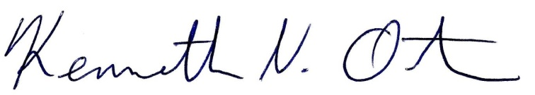
Respectfully submitted,

Kenn Ortmann
Town Administrator

