MINUTES
LIBERTY SELECTBOARD
August 26, 2019 6:00 PM

Selectboard Attendance: Melinda Steeves, 1st Selectman
Carrie Peavey, 2nd Selectman
Henry Hall, 3rd Selectman
Town Officials: Administrator Kenn Ortmann
Guest(s): Garnett Robinson, Maine Assessment & Appraisal Services

- Open Public Meeting: 6:03 PM

- Approve Minutes: Approval of the August 19, 2019 minutes was tabled to the next meeting.

- Warrant Review and Approval: Done.

- Officials/Public comments: None.

- TA informational items
  - Media stories: None.
  - Revaluation project status report: Garnett Robinson, Maine Assessment & Appraisal Services noted the many meetings he and his staff had with property owners with questions about the accuracy of the new property cards. Once the "Assessing Agent" responsibilities begin he suggests doing more research on gravel pits and creating more consistency in how we handle Personal Property. For this year the significant change in this area is to more accurately categorize utility installations as Real Property vs. Personal Property. He also said he will look closely at the number of new accounts created through this process compared to the number upon which he based his contract amount. He and the Selectboard will have further discussions about how to address the extra contract costs involved.
    - Personal Property: See discussion above.

- Old Business
  - Tax Acquired and sold property: TA Ortmann noted that several of the successful purchasers have been actively working with the Town to complete their Quitclaim deeds, but are unlikely to have them completed by August 29. The Selectboard agreed to continue working with the successful bidders to allow them to complete the paperwork.
  - Other: None.

- New Business
  - 51 Main Inc. liquor license: Pursuant to review Selectman Steeves moved and Selectman Peavey seconded approval of the renewal request. Unanimous.
  - Natural gas transmission line vegetation maintenance: TA Ortmann shared a letter from Enbridge explaining their proposed vegetation maintenance in the natural gas pipeline Right-of-Way from September through December.
  - Maine DOT notice of crack-sealing activities: TA Ortmann shared a letter from Maine DOT notifying us that there will be crack sealing of roadways in our area.
  - Other: None.

- "11th hour" items: TA Ortmann noted that he is completing the nomination of Fire Chief Gillespie for Maine Fire Chief of the Year. The Selectboard authorized him to include a letter of support from the Selectboard.

- Adjournment: 7:25 PM

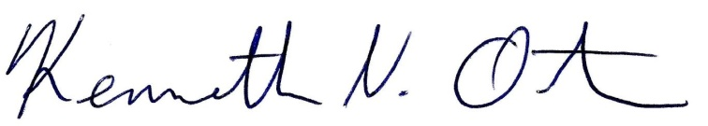
Respectfully submitted,

Kenn Ortmann
Town Administrator

