MINUTES
LIBERTY SELECTBOARD
September 9, 2019 6:00 PM

Selectboard Attendance: Melinda Steeves, 1st Selectman
Carrie Peavey, 2nd Selectman
Henry Hall, 3rd Selectman
Town Officials: Administrator Kenn Ortmann
Guest(s): Leonard W. Knowlton

- Open Public Meeting: 6:04 PM

- Approve Minutes: Pursuant to review Selectman Peavey moved and Selectman Hall seconded approval of the August 19, 2019 and August 26, 2019 minutes. Unanimous.

- Warrant Review and Approval: Done.

- Officials/Public comments: None.

- TA informational items
  - Media stories
    - Marshall Shore parking issue: TA Ortmann shared an August 29 article about the Marshall Shore parking ban in the Republican Journal.
    - Rapid Renewal service: TA Ortmann shared a September 5, 2019 article about our now offering "Rapid Renewal Service in the Republican Journal
  - Revaluation project status report: TA Ortmann noted that with Commitment tonight another phase of the Revaluation project comes to an end.

- Old Business
  - Signing Quitclaim deeds for tax-acquired properties: TA Ortmann presented Quitclaim Deeds for six of the tax acquired properties we sold for the Selectboard to sign.
  - Other: None.

- New Business
  - Action to write off taxes, interest and costs for tax-acquired properties Map 2 Lot 17A (Account 36) and Map 3 Lot 8-8 (Account 359): TA Ortmann shared that bids for nine of the eleven tax acquired properties we sold exceeded the taxes, interest and costs due the Town. In two cases the bids were less. Pursuant to review Selectman Steeves moved and Selectman Peavey seconded writing off the difference between the bid and the taxes, interest and costs due the Town for Map 2 Lot17A (Account 36) and Map 3 Lot 8-8 (Account 359). Unanimous.
  - Other - Commitment: The Selectboard joined Garnett Robinson of Maine Assessment & Appraisal Services at the computer to discuss the values entered in TRIO. Following considerable discussion about the appropriate "overlay" amount, Selectman Steeves moved and Selectman Peavey seconded a tax rate of $13.05 that will generate an overlay amount of $9,499.92. Unanimous. Mr. Knowlton expressed his concern about the increase in total taxable evaluation fo real estate and personal property from $118,490,441 last year to $165,057,787 this year. Mr. Robinson noted that a large part of the increase is due to the increase in utility valuations with the balance based on the real estate market.

- "11th hour" items: TA Ortmann mentioned that he will be on vacation October 2 – 7, but plans to attend the October 7 Selectboard meeting.

- Adjournment: 7:20 PM

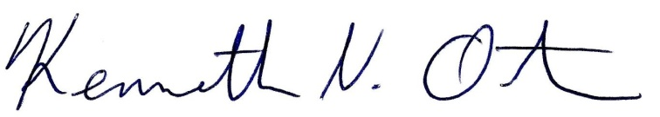
Respectfully submitted,

Kenn Ortmann
Town Administrator

