MINUTES
LIBERTY SELECTBOARD
September 16, 2019 6:00 PM

Selectboard Attendance: Melinda Steeves, 1st Selectman
Carrie Peavey, 2nd Selectman
Henry Hall, 3rd Selectman
Town Officials: Administrator Kenn Ortmann
Guest(s): None

- Open Public Meeting: 6:00 PM

- Approve Minutes: Pursuant to review Selectman Hall moved and Selectman Peavey seconded approval of the September 9, 2019 minutes. Unanimous.

- Warrant Review and Approval: Done.

- Officials/Public comments: None.

- TA informational items
  - Media stories: None.
  - Revaluation project status report: TA Ortmann noted there have continued to be some phone calls with questions and a couple of tax card errors have been identified that will require abatements.

- Old Business
  - Tax acquired and sold property: TA Ortmann noted that there are only two properties left for which we are still waiting on a quitclaim deed.
  - Liberty Craft Brewing response to noise complaint: TA Ortmann noted Mr. Hews' statements that he has adhered to the restriction that live music end at 8 PM. After reviewing the email correspondence the Selectboard asked TA Ortmann to follow up on the possibility that radio music was coming from the site while staff cleaned up.
  - Other: None.

- New Business
  - Georges River Land Trust correspondence: The Town is invited to submit comments regarding adherence to "national quality standards" to the Land Trust Accreditation Commission. The Selectboard has no comments to submit.
  - AED purchase opportunity: The Selectboard had several questions best addressed by Chief Gillespie so this item is postponed to next week.
  - Property Tax Relief correspondence: TA Ortmann noted that due to new legislation we now need to send the Office of State Treasurer a copy of the names and addresses of all property tax homesteaders.
  - Other: None.

- "11th hour" items
  - Spirit of America Foundation Tribute: The ceremony honoring our nominee, Barbara Rehmeyer, is scheduled for Thursday, October 10 at 6 PM at the Belfast Boathouse, 34 Commercial Street in Belfast.
  - Chief Gillespie officially a Chief Fire Officer Level 1: TA Ortmann informed the Selectboard that the Maine Fire Chief's Association has officially awarded Chief Gillespie his "Chief Fire Officer Level 1" designation.
  - Marshall Shore correspondence: TA Ortmann shared correspondence from Julie Beckford hoping for a town government sponsored community discussion and/or task force to see if there is a way to fine tune the parking policy to minimize ill will.
  - Draft audit: TA Ortmann noted that Treasurer Hatfield and Clerk/Tax Collector Gail Philippi are reviewing the document in detail. Selectman Peavey requested an electronic copy to review.

- Adjournment: 6:52 PM

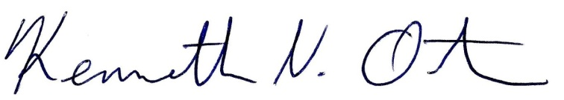
Respectfully submitted,

Kenn Ortmann
Town Administrator

