MINUTES
LIBERTY SELECTBOARD
October 28, 2019 7:23 PM

Selectboard Attendance: Melinda Steeves, 1st Selectman
Carrie Peavey, 2nd Selectman
Henry Hall, 3rd Selectman
Town Officials: Administrator Kenn Ortmann
Guest(s): None

- Open Public Meeting: 7:23 PM

- Approve Minutes: Pursuant to review Selectman Peavey moved and Selectman Hall seconded approval of the October 21, 2019 minutes. Unanimous.

- Warrant Review and Approval: Done.

- Officials/Public comments: None.

- TA informational items
  - Media stories: None.
  - Revaluation project status report: TA Ortmann will prepare the Selectboard's responses to the abatement requests for review and approval at the meeting next week.

- Old Business
  - Tax acquired and sold property: TA Ortmann noted correspondence from Kate Ahlefeld stating her hope we will have signed paperwork within the month, and possibly within the next 1-2 weeks.
  - Snow Shoveling: TA Ortmann noted that Luke Davis is not available to shovel this year. The Selectboard is contacting other individuals they think may be interested.
  - Other: None.

- New Business
  - Closing Office for Veteran's Day, November 11: The Selectboard will not be meeting Veteran's Day..
  - Review of "Application/Agreement for Holding Tank Installation", Map 21 Lot 5, Account 244: The Selectboard reviewed the application and asked TA Ortmann to bring it back for their signatures after it has been reviewed and signed by Plumbing Inspector Don Harriman.
  - Other: None.

- "11th hour" items
  - Correspondence from State regarding inspection of "Route 220 culvert": TA Ortmann shared a letter from MaineDOT stating they have completed an inspection of the "Route 220 culvert" on October 10, 2019 and located one small leak (garden hose size) from the last upstream box that they maintain is "typical".

- Adjournment: 7:39 PM

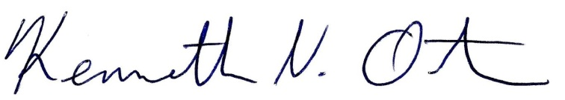
Respectfully submitted,

Kenn Ortmann
Town Administrator

