MINUTES
LIBERTY SELECTBOARD
December 9, 2019 6:00 PM

Selectboard Attendance: Melinda Steeves, 1st Selectman
Excused: Carrie Peavey, 2nd Selectman due to another obligation
Henry Hall, 3rd Selectman
Town Officials: Administrator Kenn Ortmann
Guest(s): None.

- Open Public Meeting: 6:05 PM

- Approve Minutes: Pursuant to review Selectman Steeves moved and Selectman Hall seconded approval of the December 2, 2019 minutes. Unanimous.

- Warrant Review and Approval: Done.

- Officials/Public comments: TA Ortmann reviewed a letter the Town received from State Treasurer Henry E.M. Beck updating us on the Property Tax Relief law that will result in refund checks being sent to property owners with valid Homestead Exemptions in April 2019. Since this is the first time this has happened he anticipates some problems and questions and has provided the Town with contact information for his office. All Town Office staff have this information so, if Selectboard members get asked questions about the program, TA Ortmann encouraged them to have the property taxpayer contact the Town Offices directly

- TA informational items
  - Media stories: None.

- Old Business
  - Snow shoveling: The Selectboard asked TA Ortmann to contact the individual plowing the Davis' driveway to see if he might be willing to do some limited hand shoveling.
  - Problematic subdivision: TA Ortmann stated that he has obtained copies of each deed and is now composing the letter that will be sent to the parties.
  - Other: None.

- New Business
  - Learning Center parking in Town Office parking lot & snow removal: TA Ortmann informed the Selectboard that he now has a second Learning Center Board contact person to get in touch with when there are problems. He noted they acknowledged their error in not informing parents before the first snowstorm to avoid parking in the Town Office parking lot until the snow has been cleared.
  - Other: Selectman Steeves asked TA Ortmann to draft a warrant article to cover the cost of painting the interior of the Town Offices.

- "11th hour" items: None.

- Adjournment: 7:00 PM

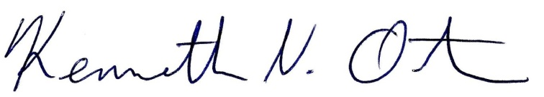
Respectfully submitted,

Kenn Ortmann
Town Administrator

