DRAFT MINUTES
LIBERTY SELECTBOARD / MONTVILLE SELECTBOARD
January 20, 2020 5:00 PM

Selectboard Attendance: Melinda Steeves, Liberty 1st Selectman
Carrie Peavey, Liberty 2nd Selectman
Henry Hall, Liberty3rd Selectman
Bob Price, Montville 1st Select Person
Cathy Roberts, Montville 2nd Select Person
Bob LeRoy, Montville 3rd Select Person
Town Officials: Liberty Town Administrator Kenn Ortmann, Liberty Clerk/Tax Collector/Registrar of Voters Gail Philippi, Liberty Road Commissioner Tammy Reynolds, Liberty Fire Chief Bill Gillespie, Liberty Treasurer Hannah Hatfield, Liberty EMA Director Elise Brown, Montville Budget Committee member Susan Shell
Guest(s): Liberty Volunteer Ambulance Service (LVAS) Chief Chris Birge

- Open Joint Meeting: 5:00 PM

- Discussion about Ambulance service: Montville 2nd Select Person Roberts initiated the discussion by stressing the themes of sustainability and accountability. The following issues were also discussed:
- billing and the challenges of collection
- some towns getting service without paying for it
- questions about the constitution of the LVAS Board
- the fact that it has been difficult to keep active LVAS Board Members
- the need for the organization to change its by-laws to allow it to comply with its own rules
- the challenges of recruiting local qualified individuals
- the need to increase salaries/stipends to remain competitive
- the benefit of increasing the service area vs. the additional personnel and equipment needed to cover a larger geographic area
- the different challenges presented by "first responder" and "transport" responsibilities
- the fact that this is a state and country-wide problem; we are not alone in struggling with this issue
- work with State Senators, Representatives and the Governor to address some specific issues
- regionalization may be inevitable but it will not be less expensive

There was consensus that the LVAS cooperation/collaboration model we adopt might become a model for other cooperative efforts between the communities such as in the area of solid waste, and that we need to begin meeting regularly to work on these issues.

LVAS Chief Chris Birge was tasked with creating a letter to the communities that can be used at Town Meeting to explain the LVAS funding request AND requesting LVAS Board member volunteers.

- Other Business: None.

- Adjournment: 6:00 PM

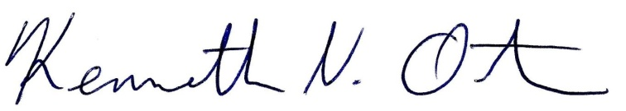
Respectfully submitted,

Kenn Ortmann
Liberty Town Administrator

