DRAFT MINUTES
LIBERTY SELECTBOARD
March 2, 2020 6:00 PM

Selectboard Attendance: Melinda Steeves, 1st Selectman
Carrie Peavey, 2nd Selectman
Henry Hall, 3rd Selectman
Town Officials: Administrator Kenn Ortmann, Emergency Management Agency Director Elise Brown, Road Commissioner Tammy Reynolds, Fire Chief Bill Gillespie
Guest(s): Duane Jewett

- Open Public Meeting: 6:00 PM

- Approve Minutes: Pursuant to review Selectman Steeves moved and Selectman Peavey seconded approval of the February 24, 2020 minutes. Unanimous.

- Warrant Review and Approval: Done.

- Officials/Public comments: None.

- TA informational items
  - Media stories: None.

- Old Business
  - Annual Report - final review: The Selectboard reviewed and reworked its report to be included in the 2019 Annual Report.
    - Mailing schedule: TA Ortmann noted that, as long as the final document is received by the printer this evening, we expect to have the printed reports delivered next Monday. The plan is to mail them out next week
  - Problematic Subdivision update: No new information.
  - Ambulance Service update: TA Ortmann has an information request in to MMA and is waiting for a response. EMA Director Brown will be meeting with Montville Selectperson Roberts to discuss this issue further. Fire Chief Gillespie reported on research he has done on communities working with an Ambulance 501 (C) (3) becoming a municipal entity. He provided a copy of the Acton Fire-Rescue Ordinance that he plans to use as a starting point to create one of our own if Town Meeting approves the initiative. At some later date Fire Chief Gillespie will initiate further discussions with Searsmont to look for opportunities for collaboration.
  - Water testing at public facilities update: Fire Chief Gillespie and Road Commissioner Reynolds reported that well water from their sites is used almost exclusively for toilets and sinks. Bottled water is used for personal consumption. On that basis, and given that neither location is a "public water supply", the Selectboard is in agreement that testing is a low priority.
  - Liberty school funding formula research update: No new information.
  - Other: None

- New Business
  - Other: Following the suggestion of Road Commissioner Reynolds that we reinstitute a meal break in the Town Meeting process, the Selectboard agreed to schedule a Potluck at 11 AM with the theme of "Bringing Community Back". TA Ortmann will post information on our WEB page.

- "11th hour" items: None.

- Adjournment: 7:37 PM

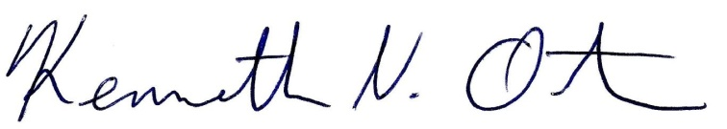
Respectfully submitted,

Kenn Ortmann
Town Administrator

