MINUTES
LIBERTY SELECTBOARD
March 27, 2020 5:30 PM

Selectboard Attendance: Melinda Steeves, 1st Selectman
Carrie Peavey, 2nd Selectman
Excused: Henry Hall, 3rd Selectman due to health precautions
Town Officials: EMA Director Elise Brown
Guest(s): None.

- Open Meeting: 5:30 PM (closed to the public due to Coronavirus - COVID-19 - situation)

- New Business
- Emergency Food boxes: The Selectboard discussed how to best meet anticipated food needs of Liberty residents. It was noted that food pantries can ask FEMA for assistance. A questionnaire will be developed to find out more specifically the needs. Following the discussion, Selectman Steeves moved and Selectman Peavey seconded approval of up to $2,000 weekly from the COVID-19 account to be reevaluated May 1, 2020. Unanimous.
- Other: None.

- Adjournment: 6:02 PM

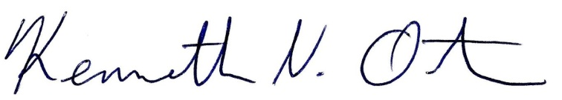
Respectfully submitted from transcription,

Kenn Ortmann
Town Administrator

